IPMS Lincoln – Scott Sumsion Chapter
November 2014
Next Meeting Novemnber 13, 2014 Bison VB Breakroom 6:30pm
Our next meeting is scheduled for Thursday Evening November 13 6:30pm
November begins what will hopefully be the rejuvenation of our chapter. At the October meeting we had a good turnout, thankfully, and everyone agreed a change was needed. While this may not be the final location, we did think it’s a good start, at least on a temporary basis but we’ll keep our eyes and ears open if something better comes to light. This location comes with no strings attached and no forced ending time.
Several good ideas were discussed last month as part of our going forward. We definitely need to plan monthly topics whether how-tos , or talks targeting a specific subject or type model. One thing I have always personally been most proud of in our chapter is that every discipline of modelling, and modeler, is welcomed. Techniques seem to be adaptable across the broad spectrum of the hobby.
But we need to get back to a regular attendance of 8-10 before most of those ideas become practical. We still want to hear ideas, and welcome anyone wanting to make a presentation stepping forward.
Chapter dues have been paid so we are up to date with our status with IPMS/USA. We are about to enter our 34th year of being a chartered chapter. Next up will be your chapter dues by January 1, 2015.
Moving beyond that, while we have nothing planned for November it will serve as getting you familiar with the new location and we can focus on more ideas to grow.
December’s meeting will be on Thursday the 11th and feature our annual gift exchange and Airfix kit contest. I am going to go out on a limb here and hopefully not invite Dan's wrath, but offer 2015 dues paid to everyone who brings a completed model built from an Airix kit. That is worth more than the kit cost you !
The gift exchange rules have not changed in forever but if you need a reminder: Bring a new kit that YOU would like to build, wrapped but with no ID of any type visible.
- Dues are payable anytime for 2015
- December will be the Airix kit contest, and
- Christmas gift exchange

This time my chosen photos are those that have won for “Best Use of IPMS Convention Decals” since 2011.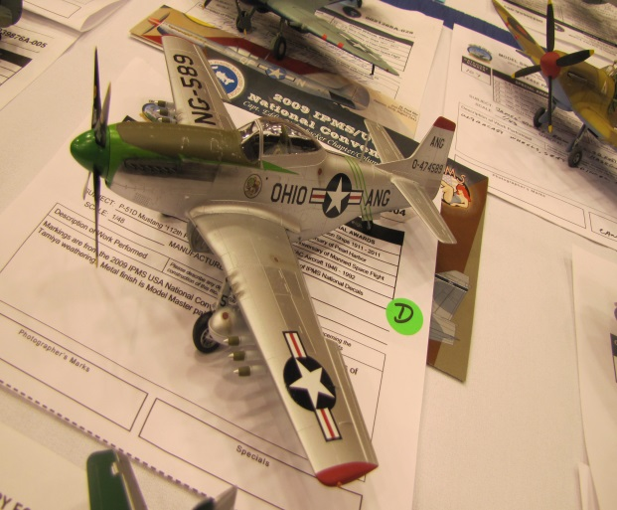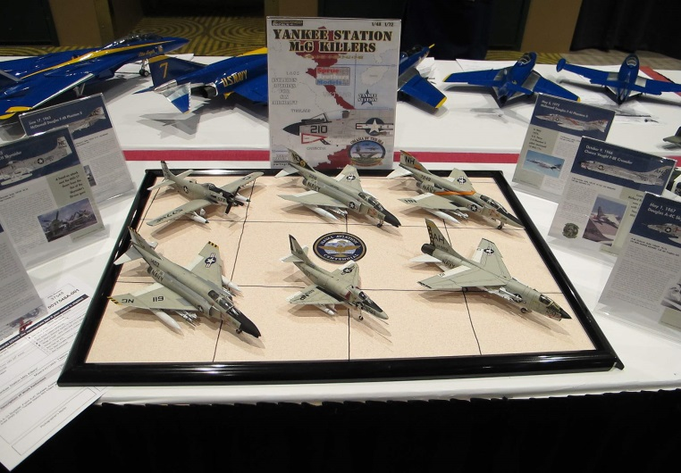
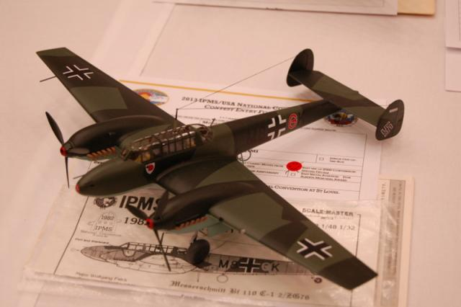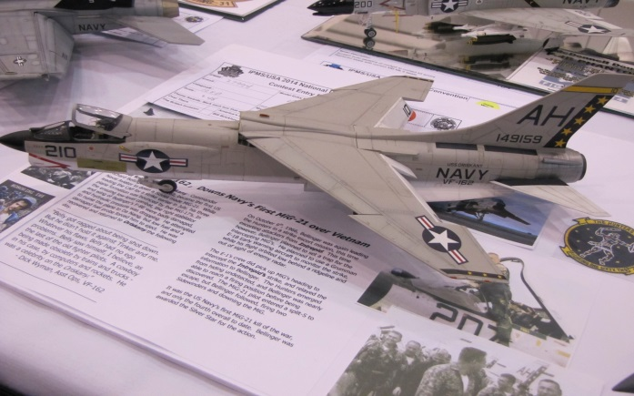

I will keep this at the bottom of the page going through the next several months.
The 2015 convention is in Columbus OH July 22-25. I have been there for 1997 and 2009 conventions and these guys do an excellent job. Its at the same Hyatt Regency as previously. Of course there is a tour scheduled to the NMAF. An important update: ALL AVAILABLEED ROOMS FOR WEDNESDAY JULY 22 are gone. Rooms remain for the rest of the convention days. If you think you’ll be going RESERVE YOUR ROOM NOW if you want to stay at the host hotel. It’s much easier to cancel later than scramble to find a room and they are being booked at a steady rate.

See page 3 for locator map of the new meeting location.

 |  |  | Park | Behind Sign
 |  |  |  | (8-10 cars)
 | 9
 | 2 |  |  |  | Marcus
 | 6 |  |  |  | Trailers |  |  | 10th
 |  |  |  |  | Lot
 | L |  |  |  |  |  |  | ST
 | S
 | t
 |  |  | <= = = | Entry Door
 |  | L ST

