IPMS Lincoln – Scott Sumsion Chapter
July 2014
Next Meeting July 12,2014 Anderson Library 1pm

Obviously a short turn-around as we get back to the 2nd Saturday------ Temporarily
Back again ! It turned out to be a good decision to delay the June meeting as many of you attended the Omacon at the Strategic Air & Space Museum. But once again the next week our attendance was again minimal. So we went ahead and made the decision to move to a Tuesday or Thursday evening as soon as Jim can work out the arrangements with the library.
A couple things of note this time. First, if you have pre-registered for the convention in Hampton VA packets are beginning to be received as they are mailing them this year. This should cut down on the long lines at the convention site.
Secondly and back on the chapter news, the Airfix kit contest has been solidly scheduled for the December meeting. The only rule is that you must build an Airfix kit, new or old. Of course the new-tool kits are much better and the line is constantly expanding it seems.
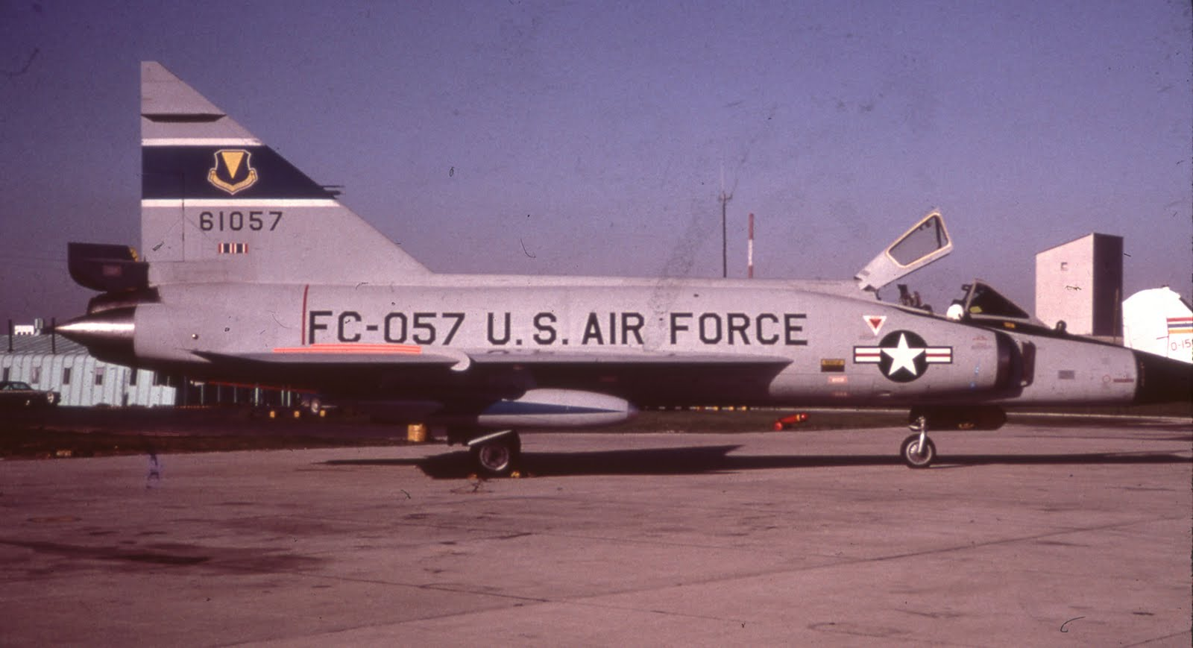
In a roundabout way I have the expected news on the new Meng F-102 CaseXX wing kit. I hadn’t seen the announcement in any magazine but noticed a decal mentioned by Xtradecal in SAMI. So I checked the Squadron site that evening and saw it was on sale at $25.99 down from $39.99. The next day it was reduced another 15% for the July 4th holiday so I bought the kit for $22.99. This kit is so much better than the old Hasegawa there is no comparison. The only problem I encountered with the Case X kit was that the canopy is hard to fit in the closed position. The new Xtradecal sheet is labelled as Pt I so obviously more are planned. Check out both the kit and the Xtradecal line at www.hannants.co.uk
Being a member of the F-105 Thunderchief Facebook page led to me not only meeting 2 local members who spent time on Thuds in Thailand, but also in meeting the son of a pilot who was lost in April 1966. A couple of us from here met Brad McCurdy and his family, back for a reunion, at the SASM on 6/18/14 and enjoyed the 2+ hours walking through the displays and visiting.
There seems to be a Facebook page for whatever your interests are and I know Dan is a member of the P-47 page. I guarantee you’ll learn a lot that you never knew if you join a page of your interest. So there’s another thing to check out.
I was asked a while back why I included so many photos seemingly with no connection. Well the answer is simply that our chapter welcomes modelers of all genres. If you build it, you’re welcome here.
So if you prefer to build:
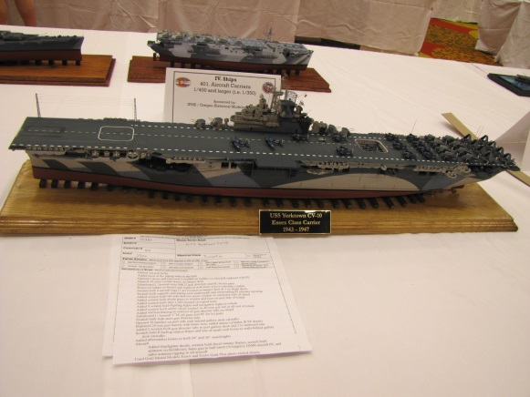

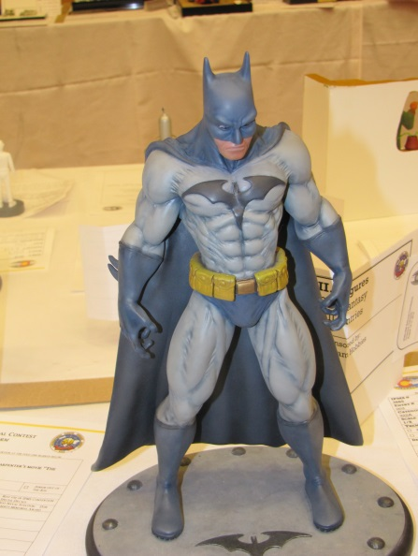
Or if you prefer

You’re welcome in all cases. By the way if you can’t tell I’m learning page layout as I go, and you guys in the Sumsion Chapter are my guinea pigs.
We hope to see you next Saturday, July 12, and bring something new, something old, something started, or something just finished.
I’ll hopefully see you there. Ron, we hope to see you again.

