IPMS Lincoln – Scott Sumsion Chapter
May 2014
You are reading the second edition of the new IPMS Lincoln online newsletter. !
NOTE: The June Meeting is Being Set Back to June 21 Due a Conflict with a Fort Crook Contest

Turnout for the May meeting was the highest in several months! We had a great discussion centered around increasing attendance and it now appears almost certain we will be moving to a weeknight. Details are yet to be ironed out but stay tuned.
Would anybody like to see a very pretty F-84 straight wing? Take a look at this.
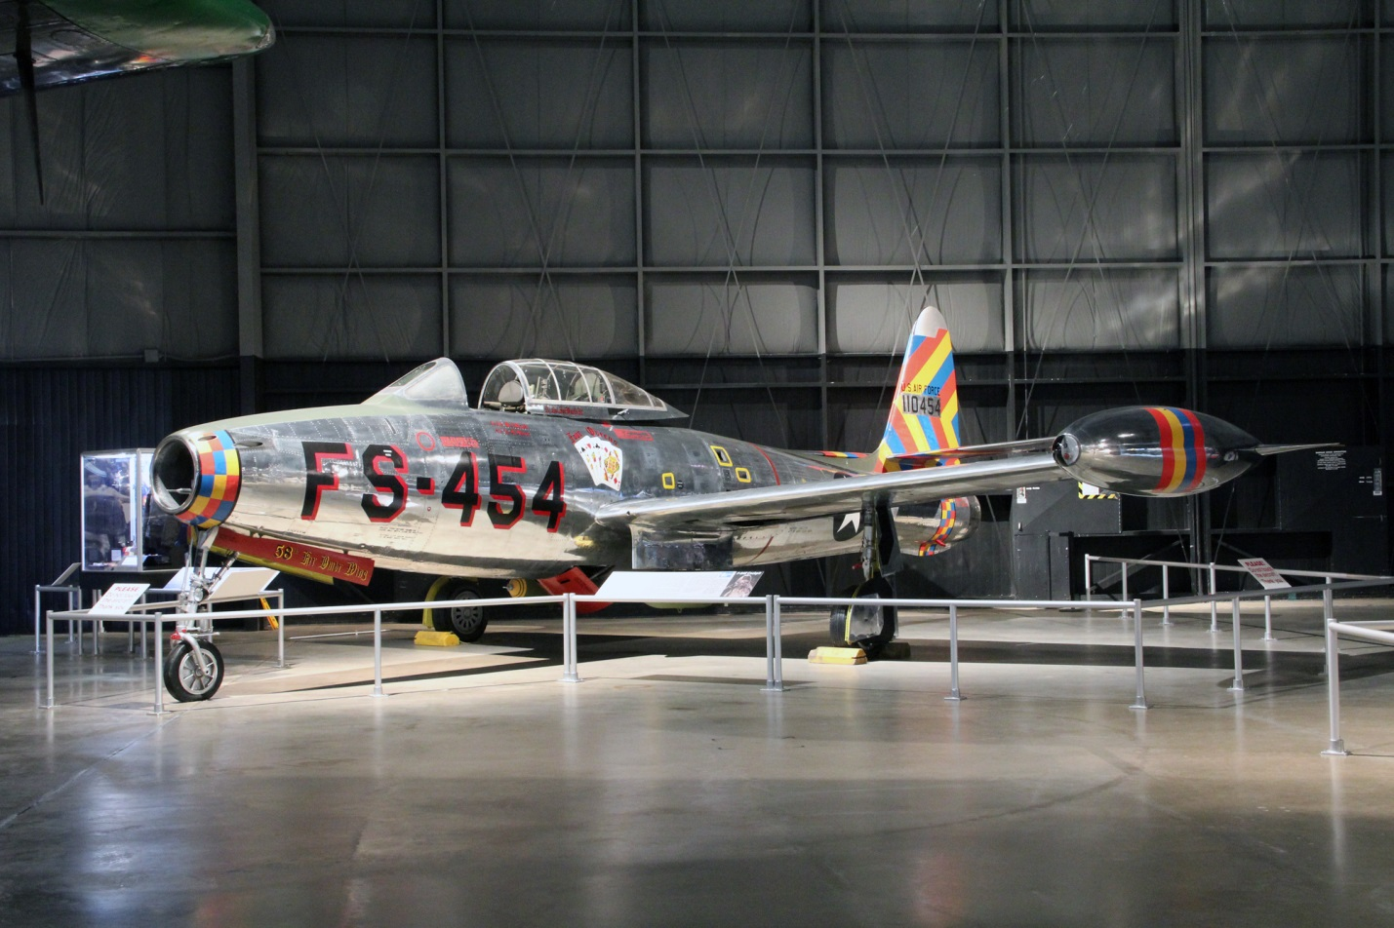
One of the real strong points of our small group is the diversity of interests. We have an award winning ship modeler, a model railroader who is something of a Sherman expert, another couple who’s main interests lie in the Sci-Fi-Fiction area, and then the aircraft and multi-interest modelers. These guys model nearly anything (Dan we won’t mention any names here.)
Now you should have noticed the heading in bold red. Fort Crook is hosting a contest/show at the SASM on June 14. While I have another obligation I’d urge the rest of you to make the short trip up I-80 and have some fun and meet more friends.
Our monthly meeting will therefore be a week later on June 21, same place and usual time. I will again bring along a few of the club’s available raffle kits and we can further discuss plans to shift meeting days and time.
But I’d like to also encourage you to bring along finished , or work-in-process models. After all models are what we are about and I think we lost our sole dedicated collector about 3 years ago now. If you have no models done or being worked on bring something: new books or magazines. Bring a selection from your stash of after-market detail parts to show off what might be in your future plans as I did last month. New kits ? Bring ‘em.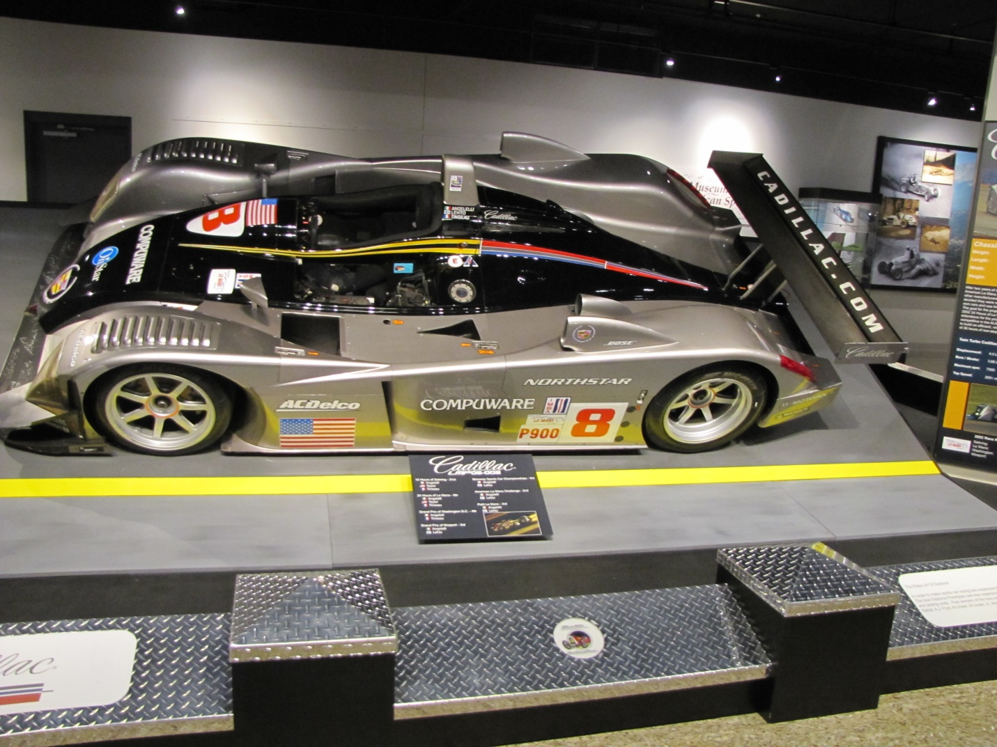
Above is a Cadillac Northstar LeMans prototype from the Speedway Museum. You’ve heard me talk about going there at least on an annual basis as the displays rotate regularly and are loaned between museums so you never know what you might see. I am about to take a Friday afternoon and go see what is new and if the expansion is completed. If you have never been there find a way to make the trip as it’s well worth the admission. Has anyone beside myself dabbled in Le Mans cars? There are some nice kits out there and they run the gamut of subjects.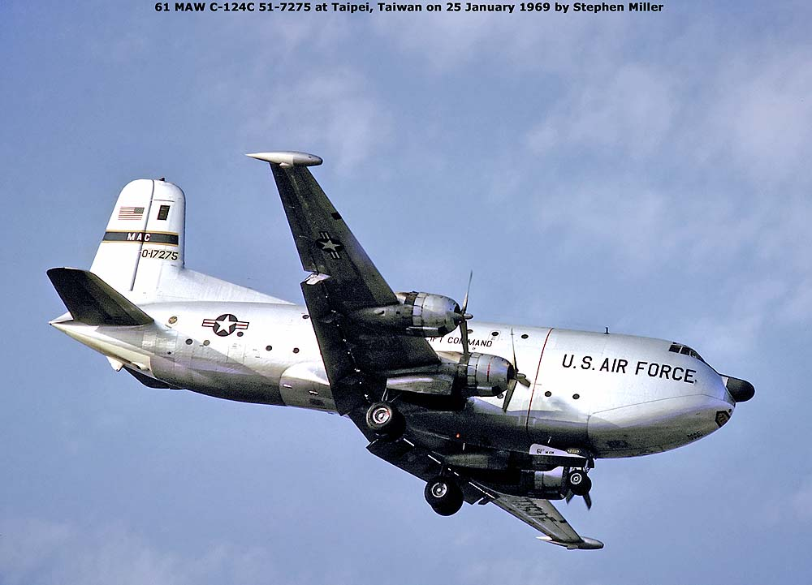
Have any of you been inside a C-124? In its day the sheer size amazed. There is a nice Roden kit available in 1/144th of both the “A” and “C” models Mine will eventually get built now that I have become a part-time worker. More modelling time!
But back to some club business. I don’t think we had our picnic last summer and I’d like to see us plan one this year. Dan has usually found a way to cajole some great steaks although its getting more difficult for him every year. We also need to set a month for our future Airfix kit contest. We also need to schedule some presentations and demos to keep interest high so bring those ideas along to the June meeting !

And now for Jim’s magazine highlites:
Airfix Mag 2014-06
p14 - Intermediate Build – Lynx HAS.3. Tom Sunley gets chilly with a build of Revell’s 1/32 Lynx HAS.3 ICE, in Antarctic operations colours.
p24 - Advanced Build – L-39 Albatros. HPH Models’ amazing 1/32 multi-media Albatros L-39 ZA is tackled by José Pires. It's his first non-styrene kit!
p34 - Out and About – Huddersfield Model Show. The event organised by IPMS Wakefield revealed its many delights to AMW’s Ian Hartup.
p36 - Exclusive Build – Higgins LCVP and Willys Jeep. Johan Augustsson creates a convincing Normandy Beach diorama with Airfix’s new 1/72 Willys Jeep and LCVP landing craft, while Dan Taylor offers an historical examination of the latter.
p48 - Out and About – Southern Expo. Glenn Sands discovers some styrene-based treats at this popular and long running event.
p52 - In Focus – C-47 Skytrain. Malcolm V. Lowe explores the pedigree of this transport legend and Alan Price offers an exclusive test shot build of the new 1/72 Airfix Skytrain kit.
p66 - Advanced Build – Sea Vampire Prototype. Kev Baxter delves into carrier aviation history with CMR’s 1/72 resin Sea Vampire.
p72 - Advanced Build – Nautilus. Garry Tobiss revels in Victorian sci-fi with Pegasus Hobbies’ beautiful Nautilus kit, inspired by the Jules Verne novel.
AFV Modeller 2014-06
p2 - Meng’s M2A3 BUSK III Bradley. Mark Neville gets stuck into the stunning new 1:35 Bradley with part one looking at the interior and the build.
p12 - Syrian T-72 Model. 1975 Master of the miniature, Alex Clark reworks the 1:72 Revell kit.
p20 - Man with a Dream. Radek Pituch talks to Roberto Aguilera about his extraordinary scale model collection.
p24 - “Jerry got His”. Radek Pituch describes his Italian campaign diorama.
p34 - “In der Falle” Part Four. Robert Doepp concludes his feature on how he built his 1:24 vignette with the Tasca Zündapp KS 750m
p54 - Sd.Kfz. 234/3 Achtrad. Antonio Martin Tello builds the Dragon kit and a dedicated scenic base.
Now remember, go back and rea the intro about our meeting date change !! Plus the Fort Crook contest.
Hopefully we can get at least the 6 from last month and if anyone has awards, models, new kits, or photos from the show feel free to bring them. Fred

